

**————————————————————**

*Methods in spatial analysis*

**————————————————————**

Lecturer： Scholz, Johannes

Stu-Name： Chen, Yuzhou

Stu-number： s1104123

Major： Applied Geoinformatics

Winter semester, 2023

# Introduction

Network analysis is a series of spatial analysis methods used to calculate and optimize spatial data based on network structures, such as paths, connections, and distances within road or telecommunication networks. The task of this assignment is to use some main techniques in network analysis to analyze Salzburg and its touristic attractions on the basis of ArcGIS online maps from multiple sources and spatial analysis tools.

# Base Data

1. **Base map.** Choose the topographic map.
2. **OSM Tourist Attractions for Europe,** showing all the interests or devices related to tourism in Salzburg, which can be found in Living Atlas Mapsets.
3. **Kindergarten,** illustrating all the kindergartens in Salzburg city, which can be found in Group.
4. **My Home Address,** indicating my address in Salzburg with a symbolized vector point, which can be created as a sketch layer.

All datasets are as follows:

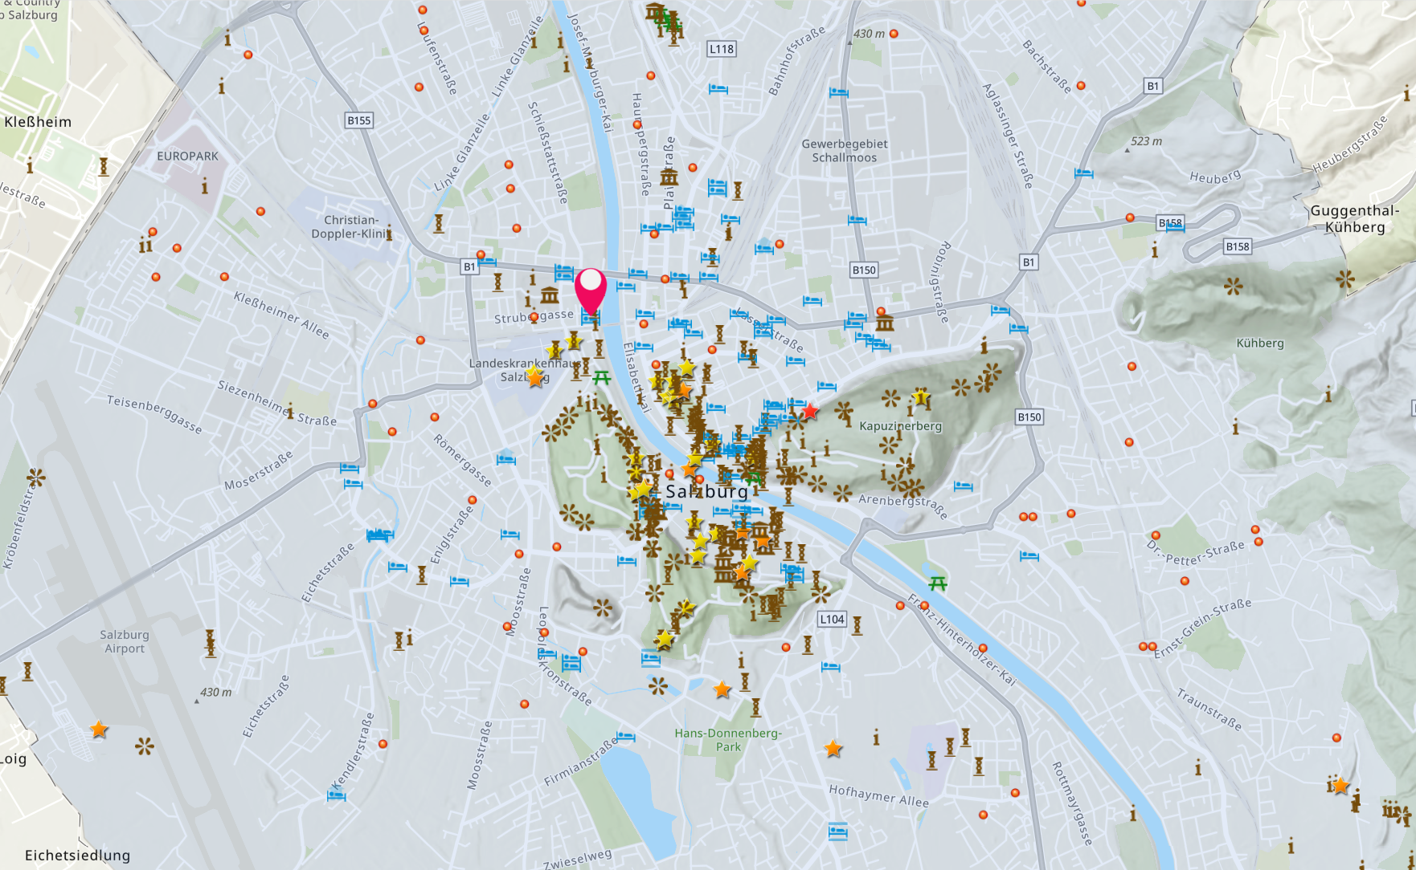

# Task 1: Find tourist attractions in different time zones

## Analysis

This task aims to find all the tourist attractions within a specific limited time zone from my home address, which contains 5, 10, 15, 20 minutes. In order to find eligible results, *Generate Travel Areas* and *Aggregate Points* tools should be used.

## Methods & Results

1. Use *Generate Travel Areas* to Generate the travel time areas with 5, 10, 15, 20 minutes time cutoffs, which stands for the walking time away from the start point. The result named *driveTimeZone* are 4 polygons cut by time length, shown as follows:

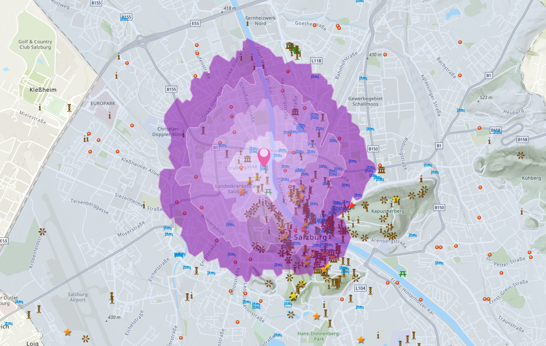

1. Then, use Aggregate Points to calculate count of points in specific polygons. Choose *Tourist attractions* as input points, and *driveTimeZone* as input polygon layer. Worth notice that the data *Tourist attractions* is in a range of whole Europe, so Processing extent should be limited to “display extent”, otherwise the credits may run out quickly. The result is as follows:

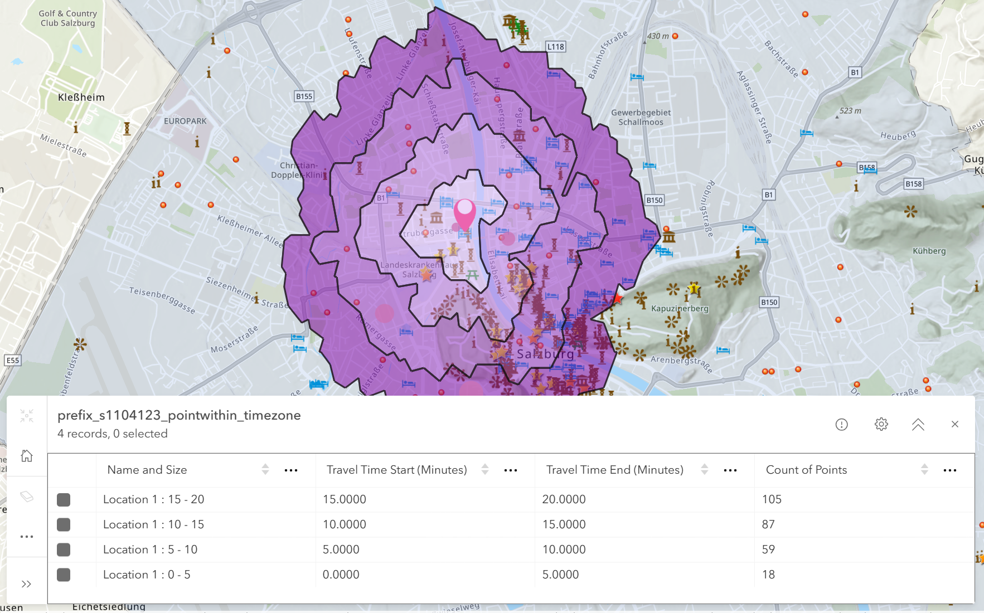

1. **Try to analyze the result table.**

Stretch the table out:

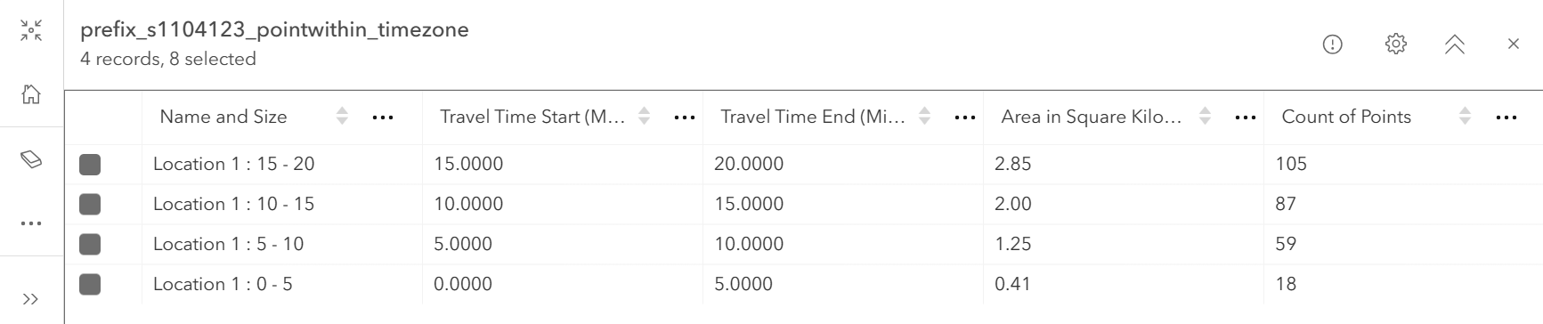

Combined with the time areas, it is easy to notice that, as the walking time gets longer, the travel time area become larger, and at the same time, the count of points within each ring-shaped area increases from 18 to 59 to 87 to 105.

Within the whole 20 minutes walking time area, there are totally 269 tourist attractions. If calculate the distribution density of the points in each time interval area, we can find that the *5-10 min* area has the highest density value, 47.2/km2, while *15-20 min* area has the lowest one, which indicates that I will have a higher probability to find a tourist attraction in the *5-10 min* area. The density formula is as follows,

$$\text{Density=}\frac{{\text{Count}}_{\text{i}}}{{\text{Area}}_{\text{i}}}\text{ (}\text{i}\text{=1,2,3,4)}$$

However, statistics is not everything. If we look into the map and the spatial distribution of tourist attractions, a large number of attractions area located on the southeast of my home. So, we’d better choose a proper direction rather that only walk for a long time to meet more attractions.

# Task 2: Find closest museums

## Analysis

The task aims to indicate 5 closest museums with respect to walking and driving around my home in Salzburg. To calculate eligible results, *Find Closest* tool and *Filters* can be used.

## Methods & Results

1. Use *Filter* to select all the museums in *Tourist attractions.* Click on the *Tourist attractions* map, and click *Filter* on the right list, and add a new filter to it. There are totally 29882 museums in Europe area, we just need to restrain our analyze extent to Salzburg.

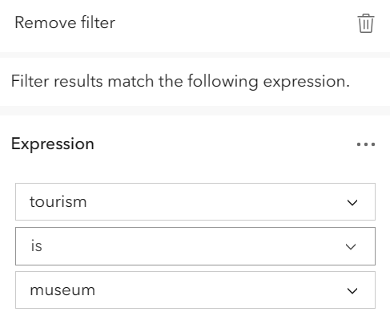

1. View the description of the *Find Closest*, which says, “find the closest features from the Near layer for each feature in the Input layer.” So we use the *home point* as Input layer, *Tourist attractions* as Near layer, max 5 number of locations, with unlimited search range(for we don’t know the possible distance). Run analysis, and the result is as follows:

|  |  |
| --- | --- |
|  |  |
|  |  |

1. **Try to analyze the result.**

It is obvious that the 5 closest museums calculated based on walking and driving time is exactly the same. But the difference lies in the route layer, especially on the route to *Mozart wohnhaus* and *Bibelwelt.*

The main reason is that, driving has different speed compared to walking, while driving speed can vary among different streets or roads, walking may keep a uniform speed, so driving time can be reduced through driving on quick roads.

# Task 3: Find closest hotels

## Analysis

The task aims to indicate 20 closest hotels around Getreidegasse using network analysis tools. To find eligible hotel results, *Find Closest* tool and *Filters* can be used.

## Methods & Results

1. Create a vector sketch of the Getreidegasse, a point but not a line.
2. Use *Filter* to select all the hotels in *Tourist attractions*. Click on the *Tourist attractions* map, and click *Filter* on the right list, and add a new filter to it. There are totally 92053 hotels in Europe area, we just need to restrain our analyze extent to Salzburg.
3. Then, use *Find Closest* to calculate 20 closest hotels around the Getreidegasse. So we use the *Getreidegasse* *line* as Input layer, *Tourist attractions* as Near layer, *Walking Distance* as measurement type, max 20 number of locations, with unlimited search range.

At the beginning, I use a line vector to sketch the *Getreidegasse*, but the result of analysis is the **linear distance**, not the **Manhattan distance** in network analysis. So I symbolize the *Getreidegasse* with a point. Run analysis.

|  |  |
| --- | --- |
|  |  |

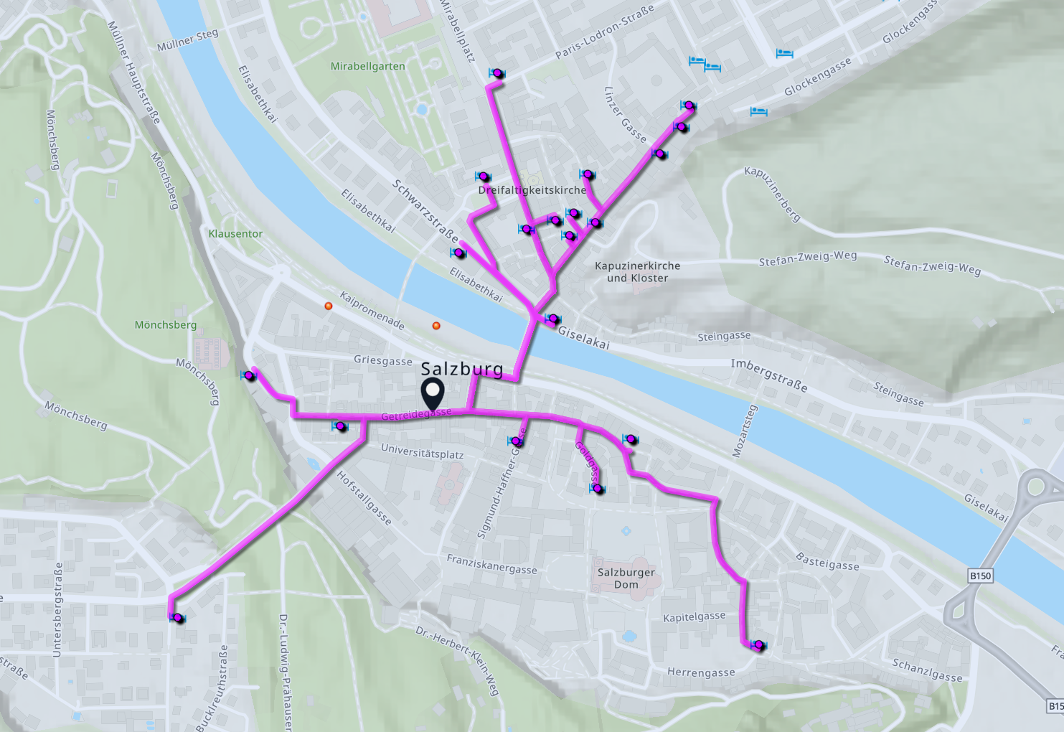

1. **Try to analyze the result.**

Among the 20 closest hotels around the Getreidegasse, there are a cluster of hotels locating on the North of the street, on the other side of the river, this may due to the bridge over the river, which connect the walking route between both river side and there are also many hotels along the Getreidegasse itself.

In my point of view, the distribution pattern of the hotels is strongly influenced by the functional zoning and geographical location of the city. The concentration of hotels on the other side of the river (north side) is due to the fact that this is the central area of Salzburg, with a high number of tourists and therefore a high number of hotels. At the same time, the Getreidegasse is a well-known commercial street and should be surrounded by a good number of hotels. Nevertheless, the south side of the Getreidegasse is far from the city center and has many hills, which makes it difficult for tourists to visit the city center and therefore has fewer hotels.

# Task 4: Find Museums near Kindergartens

## Analysis

The task aims to indicate museums in 10 minutes walking distance around Kindergarten locations using network analysis tools. One Kindergarten needs to be chosen firstly. To find eligible hotel results, tools named *Generate Travel Areas*, *Filters*, *Find by Attributes and Location* and *Calculate Travel Cost* can be used.

## Methods & Results

1. Use *Generate Travel Areas* to calculate the area within 10 minutes walking time. Choose *Kindergarten* as the Input layer, 10 minutes as the cutoff time, and adjust the processing extent. The result areas are the purple polygons shown below.

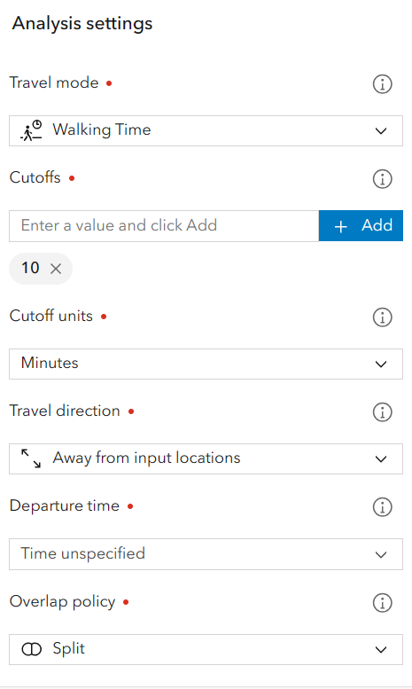 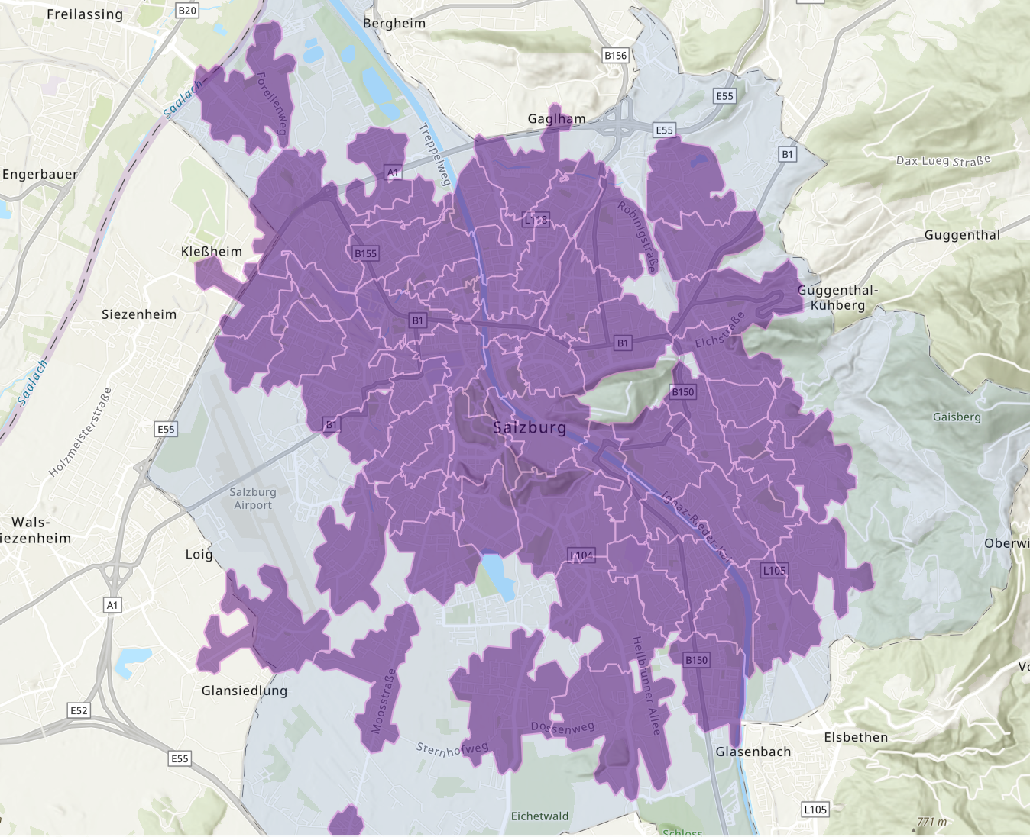

1. Use *Filter* to select all the museums in *Tourist attractions.* Methods is the same as before (Task 2). Then use *Find by Attributes and Location* to search for all the museums within the 10-minutes walking zone. All the eligible results show in pink point. According to the attribute table, the select result contains a total of 13 museums records.

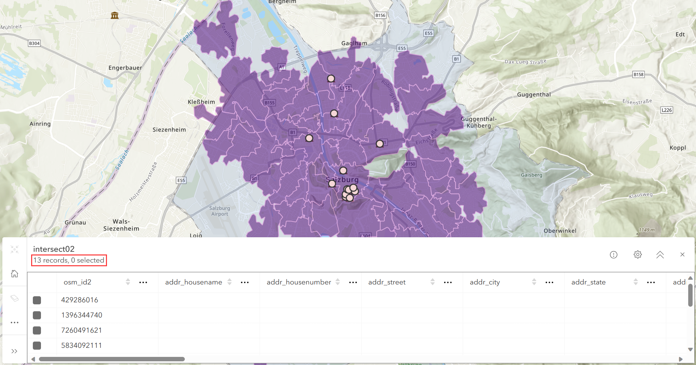

1. Then, choose one kindergarten named “BAKIP Uebungskindergarten” using filter, and use tool *Calculate Travel Cost* to calculate the routes from this kindergarten to the selected museums. So, input *Kindergarten* as From layer, selected museums as To layer. And there are 3 kinds of vehicles to be chosen, driving, trucking and rural driving.

|  |  |
| --- | --- |
|  |  |
|  |  |
|  |  |

1. **Try to analyze the result**

The analysis of walking distances from kindergartens to museums reveals a close connection between early childhood education facilities and public museums in Salzburg city. Many kindergartens have access to educational resources within a 10-minute walk. Considering the administrative boundaries of Salzburg and the distribution of museums within its area, I found that there are a total of 15 museums in Salzburg, with 13 of them located within a 10-minute walking area of kindergartens, indicating high accessibility.

Additionally, among the three modes of transportation considered for calculating travel routes, the results for the Driving and Rural driving modes are identical. The driving time for both modes is also exactly the same. However, there is a significant difference in the route calculated for the Trucking mode. Upon comparison, it is evident that the Trucking mode shares the same route and time only when traveling to museums numbered 1, 8, 10, 11, and 12. There are notable differences in other routes, particularly when choosing the route to Museum 2. In this case, the Trucking mode directly selects the route passing through Monchsberg, resulting in a faster time of approximately 24 seconds compared to the route chosen by the Driving mode.